

Definition:



**Example:** 2.2: An experiment consists of flipping a coin and then flipping it a second time if a head occurs. If a tail occurs on the first flip, then a die is tossed once. Write the sample space of the experiment.

S = {HH, HT, T1, T2, T3, T4, T5, T6}

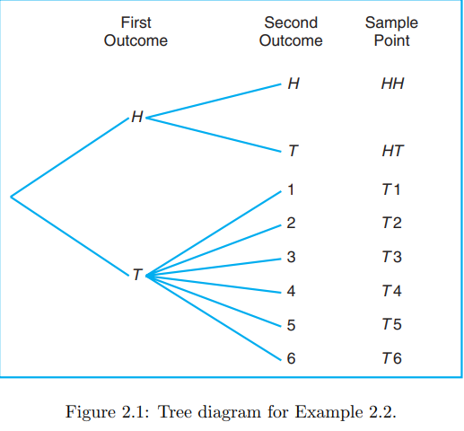

Que 2.5: An experiment consists of tossing a die and then flipping a coin once if the number on the die is even. If the number on the die is odd, the coin is flipped twice. Using the notation 4H, for **Example:**, to denote the outcome that the die comes up 4 and then the coin comes up heads, and 3HT to denote the outcome that the die comes up 3 followed by a head and then a tail on the coin, construct the sample space S.

Que 2.5: An experiment consists of tossing a die and then flipping a coin once if the number on the die is even. If the number on the die is odd, the coin is flipped twice.

1. What is the probability of the event that the number on the die is less than 3?
2. What is the probability of the event that the two tails occur?



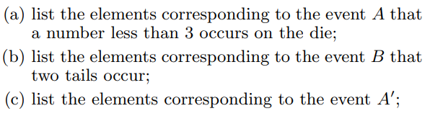

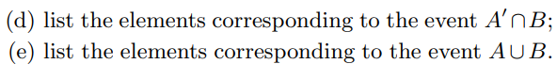

**Example::**



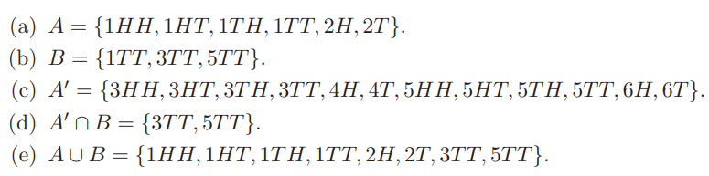

Que. 2.7 Four students are selected at random from a chemistry class and classified as male or female. List the elements of the sample space S1, using the letter M for male and F for female. Define a second sample space S2 where the elements represent the number of females selected.

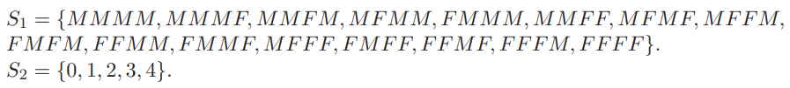

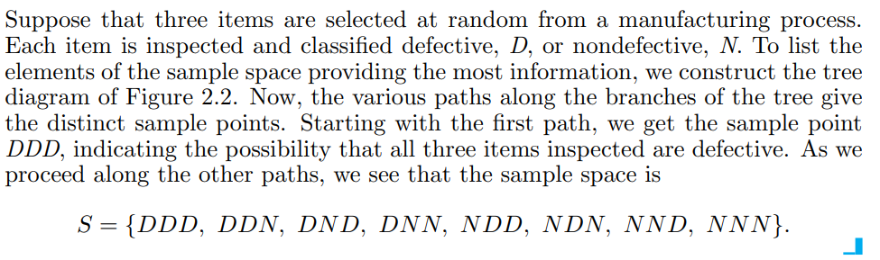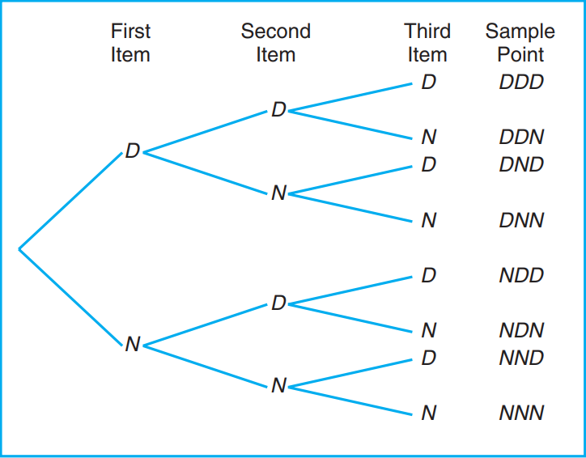

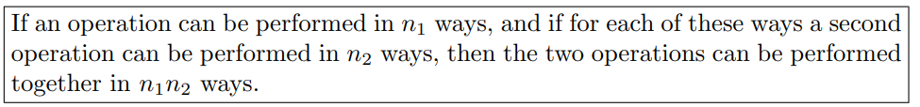

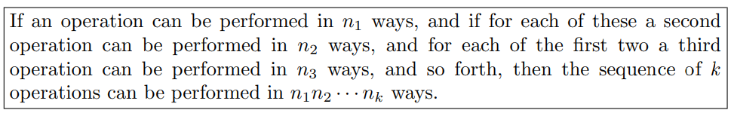

**Example:**

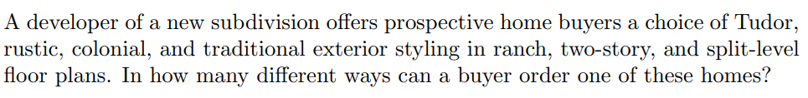

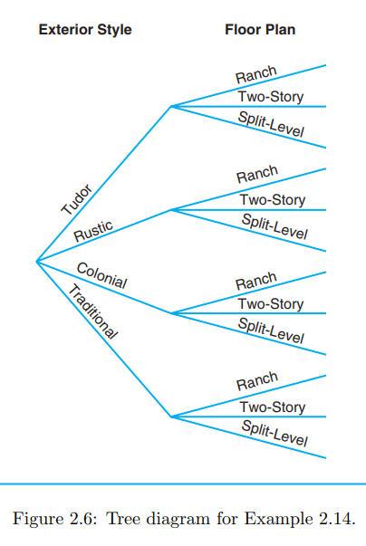

**Example::**



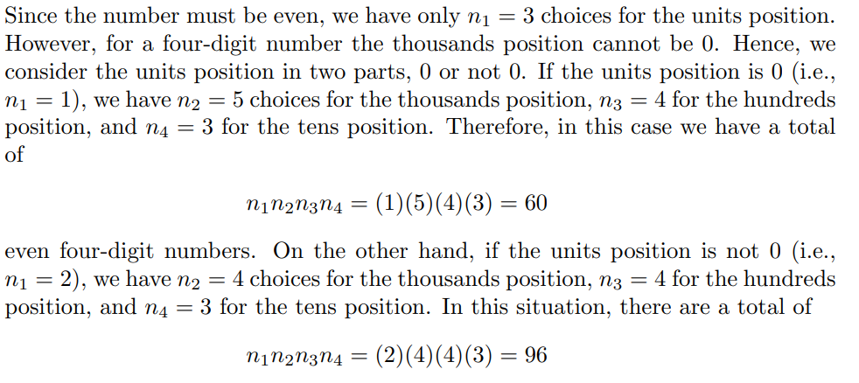

Definition 2.7: A permutation is an arrangement of all or part of a set of objects.

Theorem 2.1: The number of permutations of n objects is n!.

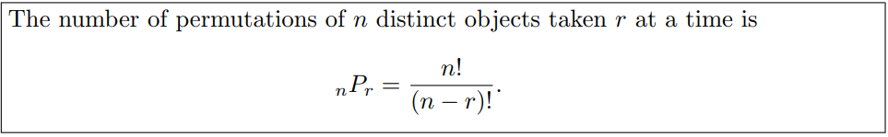

**Example::**

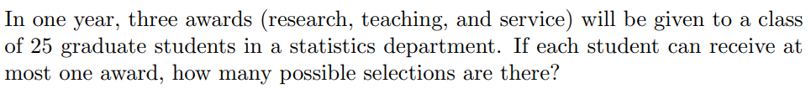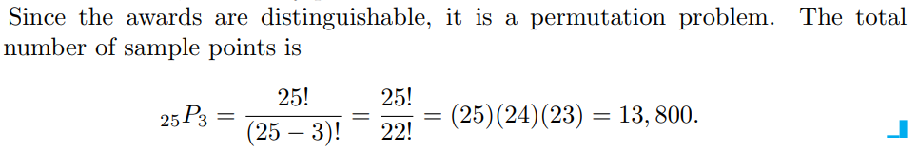

**Example::**

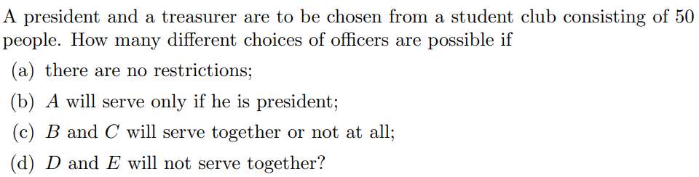

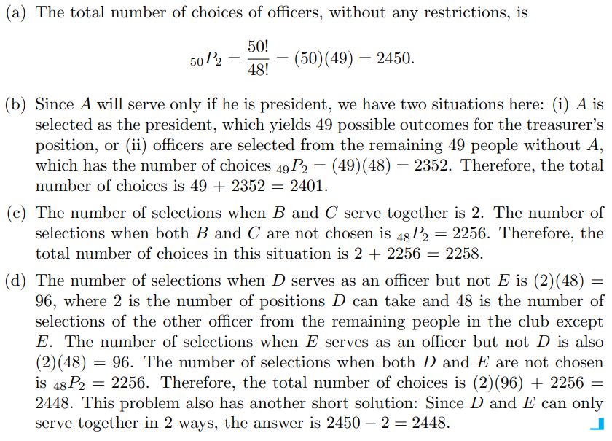

Theorem 2.3: The number of permutations of n objects arranged in a circle is (n − 1)!.

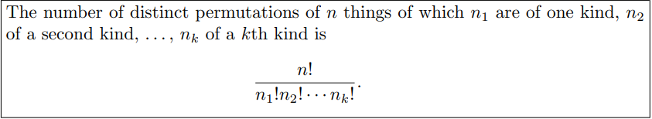

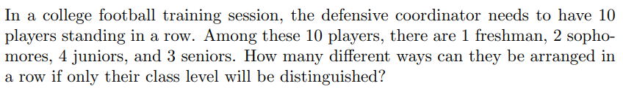

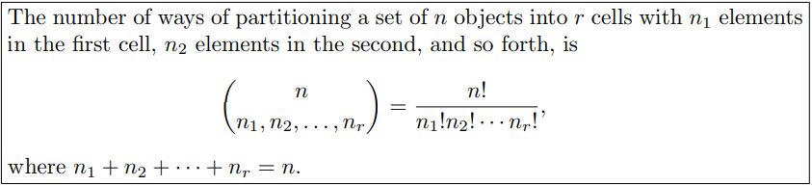

**Example:** 2.21: In how many ways can 7 graduate students be assigned to 1 triple and 2 double hotel rooms during a conference?

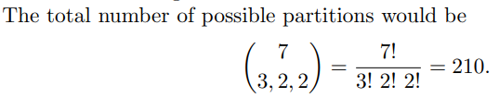

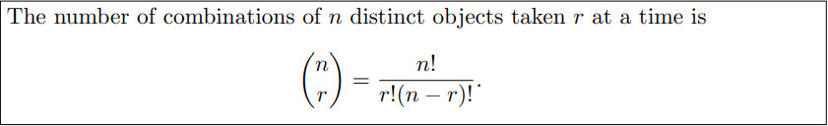

Que. A college plays 12 football games during a season. How many ways can the team end the season with 7 wins, 3 loses, and 2 ties?

**Example:** A young boy asks his mother to get 5 Game-Boy cartridges from his collection of 10 arcade and 5 sports games. How many ways are there that his mother can get 3 arcade and 2 sports games?

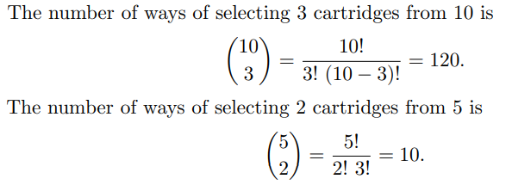



**Example:** How many different letter arrangements can be made from the letters in the word STATISTICS?

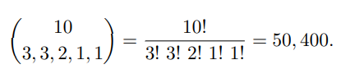

**Example:** In a random arrangement of the letters of the word ‘COMMERCE’, find the probability that all the vowels come together.

**Example:** ‘7’ persons are seated on ‘7’ chairs around a table. The probability that three specified persons are always sitting next to each other is:

(a)1/4                    (b)1/5                 (c)1/6                    (d) 1/3.

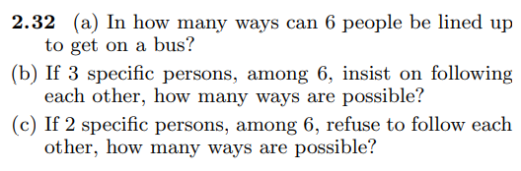

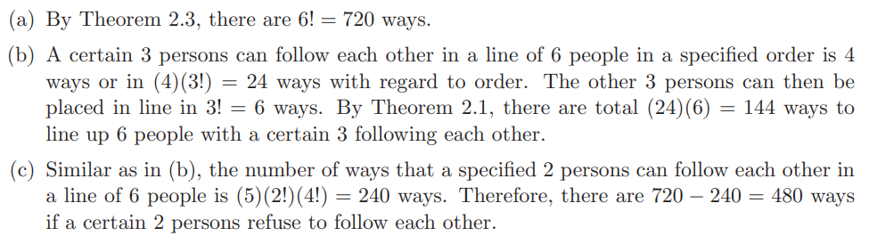

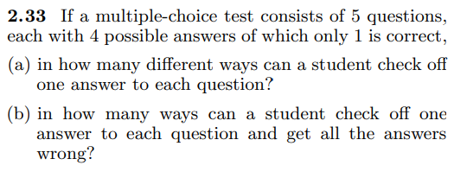

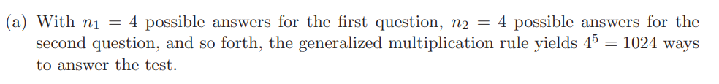

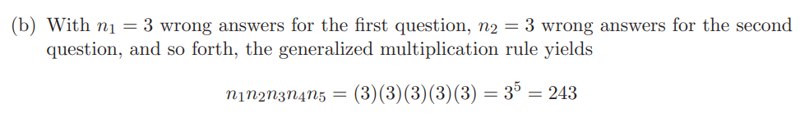

**Example:** In a poker hand consisting of 5 cards, find the probability of holding 2 aces and 3 jacks.

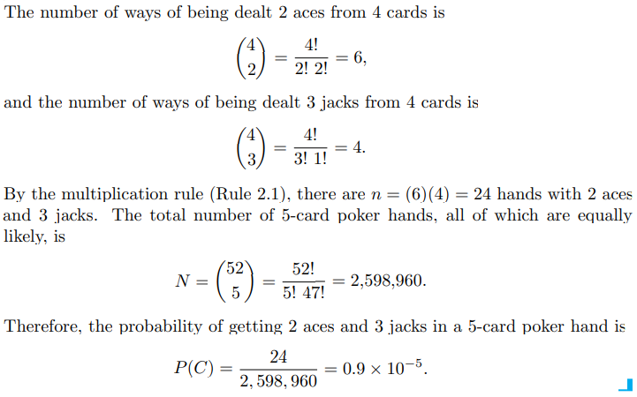

Q. A man is dealt/ given 5 hearts cards from a pack of 52 cards. If he is given 4 more additional cards, then the probability that at least one of the additional cards is also a heart is:

(a) 39C4/52C5 (b)1-(39C4/47C4) (c)39C4/47C4  (d) None of these.

Q. In how many ways can 4 boys and 5 girls sit in a row if the boys and girls must alternate?

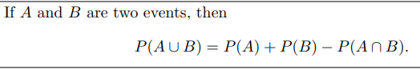

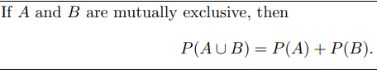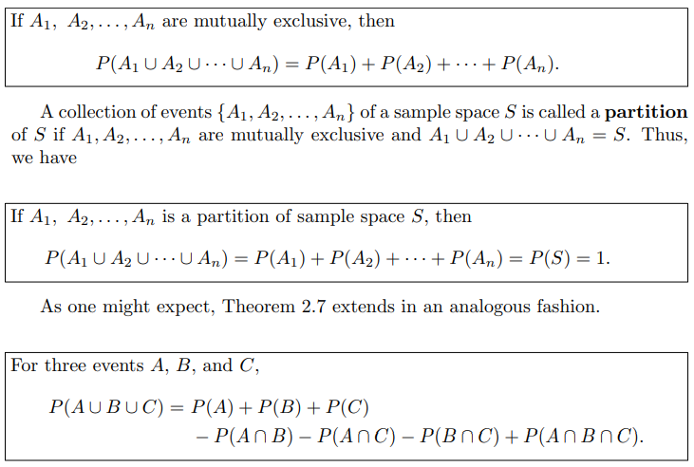

**Example:** An MBA applies for a job in two firms X and Y. The probability of his being selected in firm X is 0.7, and being rejected at firm Y is 0.5.The probability of at least one of his applications being rejected is 0.6. What is the probability that he will be selected in one of the firms?

(a) 0.2                    (b) 0.8                 (c) 0.7                    (d) None of these.

**Example:** A,B,C are three mutually exclusive and exhaustive events associated with the random experiment. Given that and then

(a) 4/9                    (b) 9/13                 (c) 4/13                    (d) None of these.

Que. Suppose that in a senior college class of 500 students it is found that 210 smoke, 258 drink alcoholic beverages, 216 eat between meals, 122 smoke and drink alcoholic beverages, 83 eat between meals and drink alcoholic beverages, 97 smoke and eat between meals, and 52 engage in all three of these bad health practices. If a member of this senior class is selected at random, find the probability that the student

(a) Smokes but does not drink alcoholic beverages;

(b) Eats between meals and drinks alcoholic beverages but does not smoke;

(c) Neither smokes nor eats between meals.

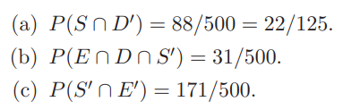

Que. In a high school graduating class of 100 students, 54 studied mathematics, 69 studied history, and 35 studied both mathematics and history. If one of these students is selected at random, find the probability that (a) the student took mathematics or history; (b) the student did not take either of these subjects; (c) the student took history but not mathematics.

Que. If five dice are rolled, what is the probability of getting four of a kind?